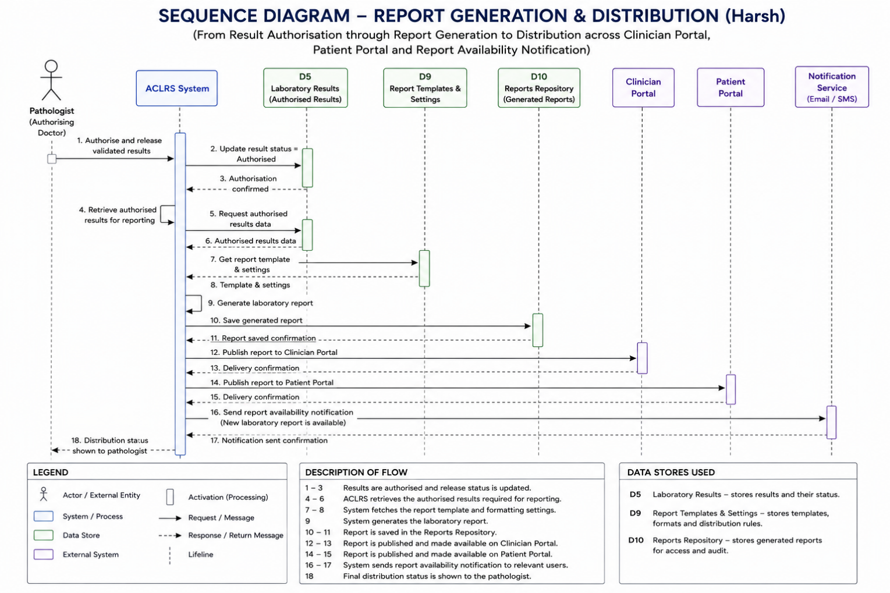
Sequence Diagram: Report Generation & Distribution - Harsh

